Experiment 4.2
Causal/Non-Causal System
Aim:
To analyze and distinguish between causal and non-causal discrete-time systems. The Aim is to understand how causality affects the system's response to different input sequences.
Program:
% Causal and Non-Causal Systems
clc;
clear;
close all;
% Input sequence
n = 0:10;
x = [1 2 3 4 5 6 7 8 9 10 11];
% Causal System: y(n)=x(n)+x(n-1)
y_causal = filter([1 1],1,x);
% Non-Causal System: y(n)=x(n)+x(n+1)
y_noncausal = x + [x(2:end) 0];
% Plotting
figure;
subplot(3,1,1);
stem(n,x,'filled');
grid on;
title('Input Sequence x(n)');
xlabel('n');
ylabel('Amplitude');
subplot(3,1,2);
stem(n,y_causal,'filled');
grid on;
title('Causal System Output y(n)=x(n)+x(n-1)');
xlabel('n');
ylabel('Amplitude');
subplot(3,1,3);
stem(n,y_noncausal,'filled');
grid on;
title('Non-Causal System Output y(n)=x(n)+x(n+1)');
xlabel('n');
ylabel('Amplitude');
Output Waveform:
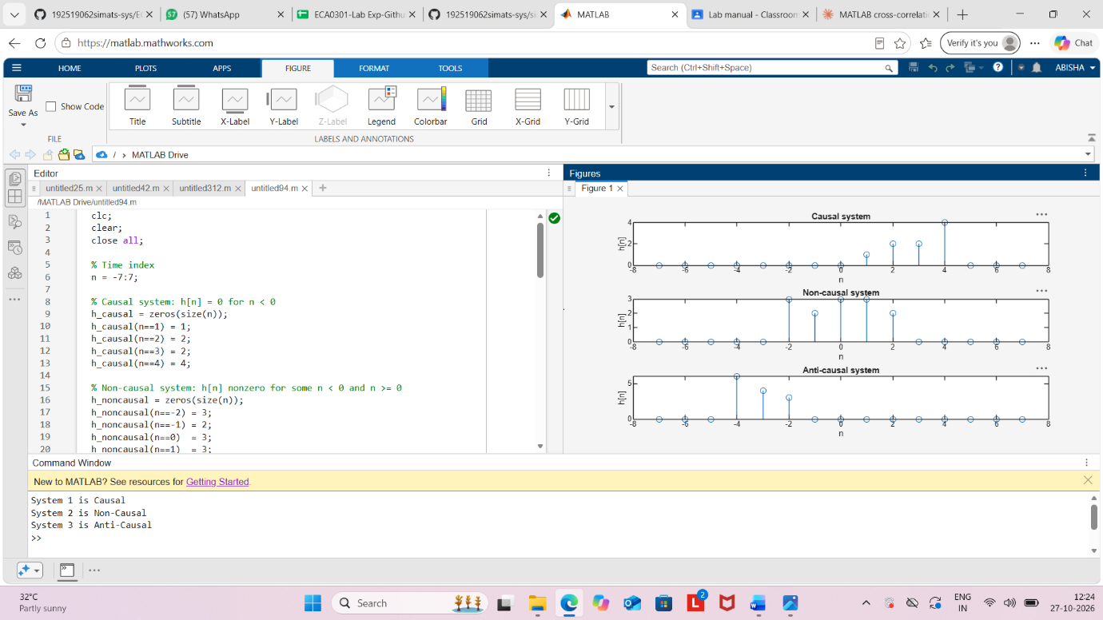

Result:
The causal and non-causal discrete-time systems were implemented successfully using MATLAB. The causal system used present and past input samples, whereas the non-causal system used present and future input samples. The corresponding outputs were obtained and displayed using stem plots.

